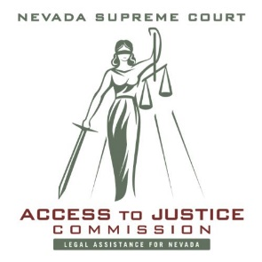

Government Sponsored Rental Assistance Programs, Legal Aid Programs and Self Help Centers

Government Sponsored Rental Assistance Programs
https://housing.nv.gov/Resources/COVID-19/Renter_Assistance/

Legal Aid Programs
North
Volunteer Attorney’s for Rural Nevadans (VARN) in Carson City: 775.883.8278
www.varn.org
Washoe Legal Services in Reno: 775.329.2727
www.washoelegalservices.org

South
Legal Aid Center of Southern Nevada in Las Vegas: 702.386.1070
www.lacsn.org
Southern Nevada Senior Law Program in Las Vegas: 702.229.6596
www.snslp.org

Statewide
Nevada Legal Services: 702.386.0404 OR 775.284.3491
www.nlslaw.net

Court Self Help Programs

Civil Law Self Help Center - Clark County Regional Justice Center
200 Lewis Ave, Las Vegas, NV 89101 - Open
702.671.3976
www.civillawselfhelpcenter.org

Washoe County Law Library
Currently closed to in-person visits
775.328.3250
https://www.washoecourts.com/lawlibrary/onlineresources

